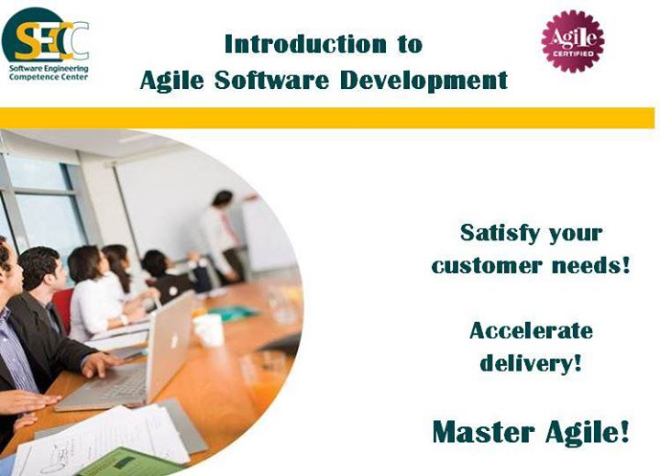

**Schedules**

·  **Course Date**: **23 - 26 September 2013**

·  **Exam Date: 8 October 2013**

**Deadline**

Make sure to register before

**8, September 2013**

**Fees**

**1500 EGP**(including a seat in the Agile Foundation Certificate exam).

**Note:** The course fees will be the same even the attendee doesn’t take the exam.

**Registration:** [**http://www.secc.org.eg/Agile_Registration.asp**](http://www.secc.org.eg/Agile_Registration.asp)

**Description**

· **Introduction to Agile Software Development**

**(4 Day Course)**

This training course provides a comprehensive introduction for Agile concepts, methods and techniques. In addition, it beefs you up with an inclusive overview of almost all Agile software development areas augmented by abundant examples, crowded exercises and many discussion topics.

**SECC Agile Foundation Certification**

·         The SECC Agile Foundation Certification (AFC) is designed to provide management with a documented level of assurance that team members are equipped with the right blend of skills and knowledge and competent enough in fundamental Agile practices.

·         To gain the required Agile related knowledge, carefully study the recommended list of material and prepare for the exam.

Examination Handbook: to access the handbook, please visit: [SECC Agile Foundation Certificate Examination Handbook](https://www.facebook.com/notes/software-engineering-competence-center-secc/introduction-to-agile-software-development/519091144836584).

**Instructors Bios**

· **Eng.** [**Ameer Hussein Gaafar**](https://www.facebook.com/notes/software-engineering-competence-center-secc/introduction-to-agile-software-development/519091144836584)

· **Eng.** [**Mohamed Amr**](https://www.facebook.com/notes/software-engineering-competence-center-secc/introduction-to-agile-software-development/519091144836584)

**Day Agenda**

-The training day will start from 9:00 am till 4:00 pm

-The instructor will manage the course agenda through the sessions.